Project Initialization and Planning Phase

Date | 28 January 2026
Team ID | LTVIP2026TMIDS65516
Project Name | AutoSage App Using Gemini Flas
Maximum Marks | 3 Marks
Define Problem Statements:
Customers who want to buy or compare two-wheelers and four-wheelers often find it difficult to get clear and complete vehicle information in one place. They try to understand details such as brand, model, mileage, features, price, and resale value, but the information is scattered across multiple websites. Most platforms require manual searching and reading long, complex specifications, which is time-consuming and confusing. Existing systems do not use image-based AI to provide instant and structured insights. This makes customers feel frustrated, unsure, and less confident while making vehicle-related decisions.
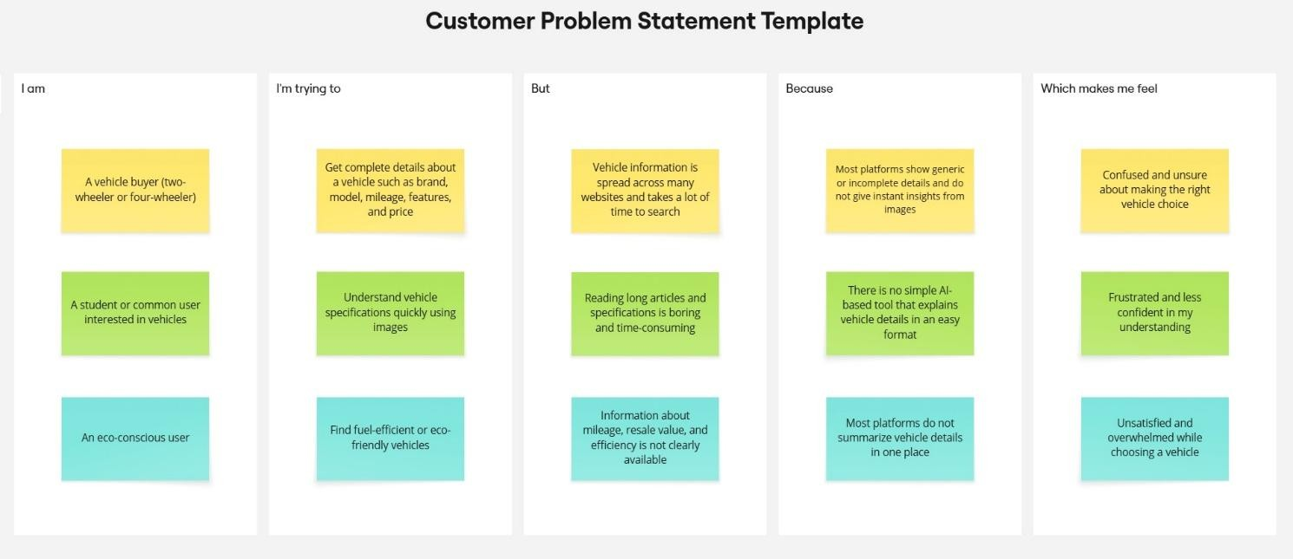

Problem Statement (PS) | I am (Customer) | I’m trying to | But | Because | Which makes me feel
PS-1 | A vehicle buyer | Understand vehicle details before buying a bike or car | Searchin g for vehicle informati on takes too much time | Vehicle details are spread across many websites and need manual comparison | Confused and unsure about choosing right vehicle

PS-2 | A student or general user | Identify and understand a vehicle using its image | Reading ling specificat ions and reviews is difficult | Most platforms do not support image-based vehicle analysis | Frustrated and less confident
PS-3 | An eco- conscious user | Find fuel- efficiency or eco-friendly vehicles | It is hard to get clear informati on about mileage and efficienc y | Vehicle information is not summarized in one place | Dissatisfied and overwhelmed

